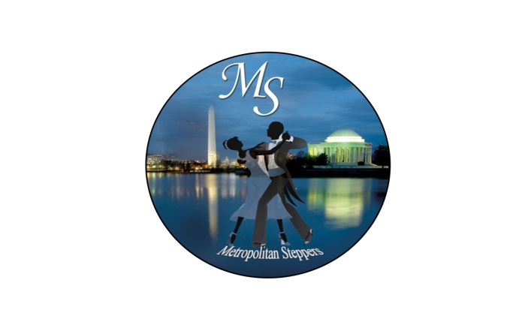
METROPOLITAN STEPPERS (MS)
HOTEL RESERVATIONS OPEN/EARLY BIRD TICKETS AT $75 (LIMITED TIME ONLY)
https://metropolitansteppers.wixsite.com/steppers

Metropolitan Steppers is hosting its 6th Annual Steppers’ Event “STEPPIN' IN OUR NATION’S CAPITAL” October 17-20, 2019
HOST HOTEL - Crystal Gateway Marriott Hotel
1700 Jefferson Davis Highway, Arlington, VA 22202
Group Rate: $139/night plus tax - Reservation Code - "MS 2019"
Rooms are available for those you would like to arrive on Thursday and depart on Monday. One night guaranteed is required. Self-parking is $19.00 per day.
CUTOFF: SEPTEMBER 26, 2019
Call today! 1-877-212-5752 or 1-703-920- 3230
To make hotel reservations hold control key and click on link or cut and paste link into browser:
https://book.passkey.com/e/49908554

THURSDAY NIGHT, OCTOBER 17, 2019 PRE-PARTY AT HOST HOTEL - $15 AT DOOR ONLY

WEEKEND PACKAGE TICKETS AVAILABLE MAY 1st
@ $75 UNTIL MAY 31st (NO REFUNDS)
Online purchases available: https://metropolitansteppers.wixsite.com/steppers or https://www.eventbrite.com/e/metropolitan-steppers-6th-annual-steppin-in-our-nations-capital-october-17-20-2019-tickets-60437152149

LIMITED NUMBER OF RESERVE TABLES AVAILABLE ONLINE MAY 1st!!!

VENDOR OPPORTUNITIES: Make your arrangements NOW. You can showcase your products and services at the event by contacting Farnese Hicks at hicksfj1946@verizon.net

FOR ADDITIONAL INFORMATION PLEASE VISIT OUR WEBSITE AT: https://metropolitansteppers.wixsite.com/steppers.

AIRPORT INFORMATION: Ronald Reagan Washington National Airport (DCA) only 5 minutes away. Hotel provides free shuttle to and from airport every 15 minutes. No rental car really needed! Baltimore Washington Airport is 45 minutes away. BWI airport provides free shuttle to and from AMTRAK/MARC train station every 5 minutes.

